Chapter 16, Problem 25.

Calculate v(t) for t > 0 in the circuit of Fig. 16.48.

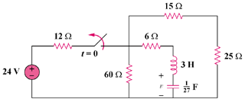

Figure 16.48
For Prob. 16.25.

Step 1. First solve for the initial conditions. Then simplify the circuit and then convert it into the s-domain and then solve for v(t). Since the capacitor becomes an open circuit, i_{L}(0) = 0 and v(0) = (24)24/36 = 16 volts.

6 Ω

24 Ω

I

t = 0

+

V

−

3s

27/s

24V

+
−

12 Ω

16/s

+
−

We can now use mesh analysis to solve for V(s). (30+3s+27/s)I + 16/s = 0 or
[3(s²+10s+9)/s]I = –16/s or I = –(16/3)/[(s+1)(s+9)] and v = (27/s)I + 16/s.

Step 2. V = –(16/3)(27)/[s(s+1)(s+9)] + 16/s = –144/[s(s+1)(s+9)] + 16/s. Thus,

V = [A/s]+[B/(s+1)]+[C/(s+9)] where A = –(144/9)+16 = 0 (as expected) and
B = –144/[(–1)(–1+9)] = 144/8 = 18 and C = –144/[(–9)(–9+1)] = –144/72 = –2.

v(t) = [18e^{–t}–2e^{–9t}]u(t) volts.

